**PIZZA SALES SQL QUERIES**

1. KPI’s
2. Total Revenue:

SELECT SUM(total_price) AS Total_Revenue FROM pizza_sales

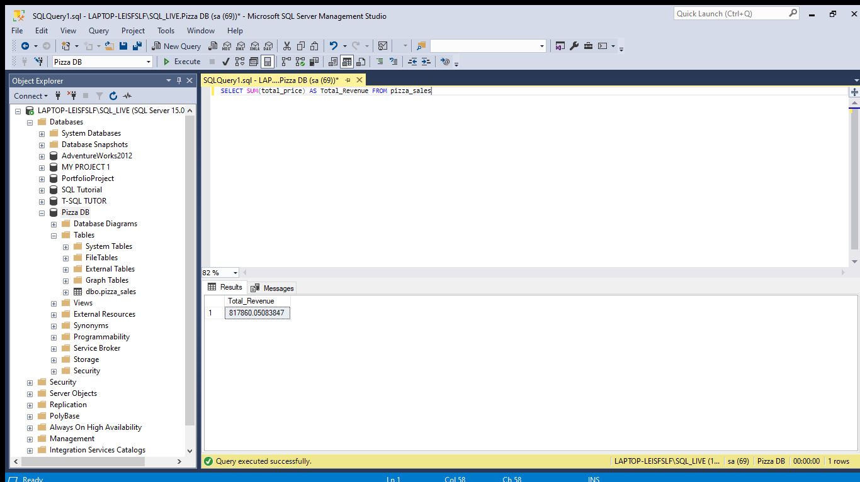

1. Average Order Value:

SELECT SUM(total_price) / Count (Distinct order_id) as Avg_Order_Value FROM pizza_sales

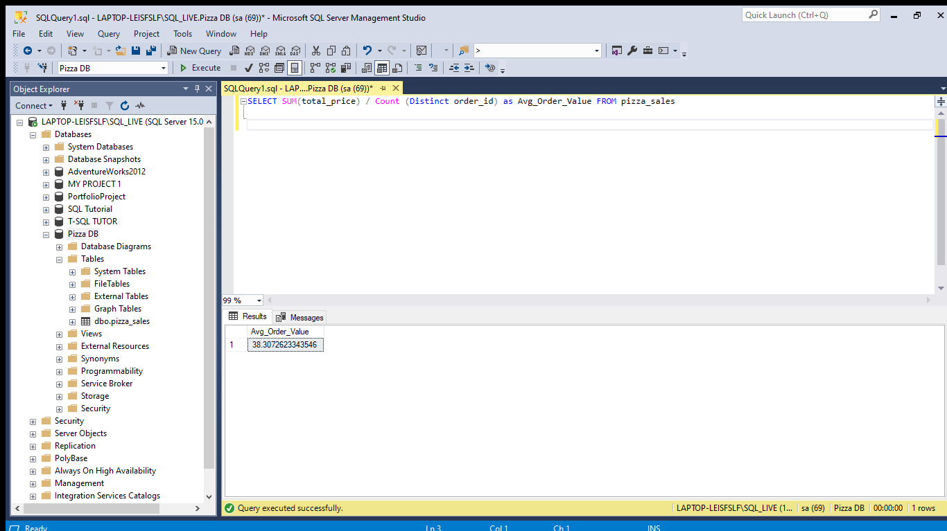

1. Total Pizza Sold:

SELECT SUM (quantity) AS Total_Pizza_Sold FROM pizza_sales

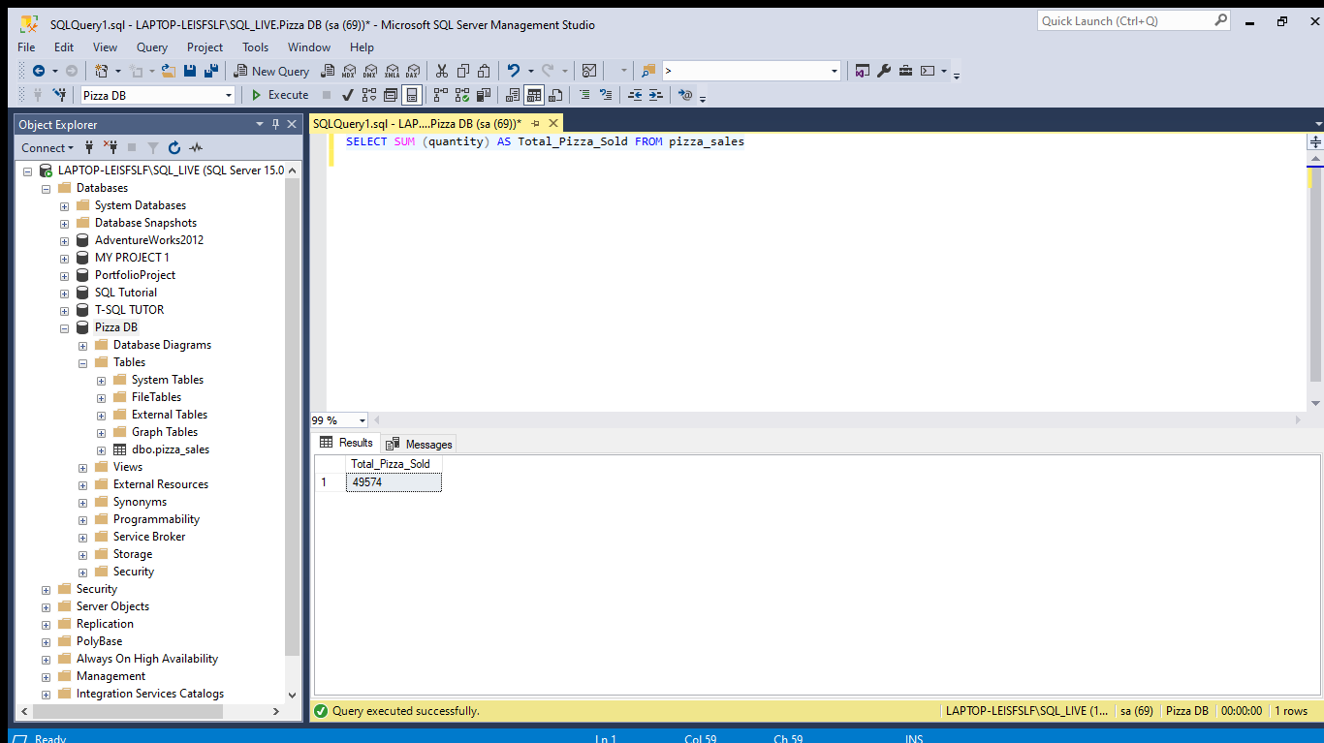

1. Total Order:

SELECT COUNT(Distinct order_id) AS Total_Orders From pizza_sales

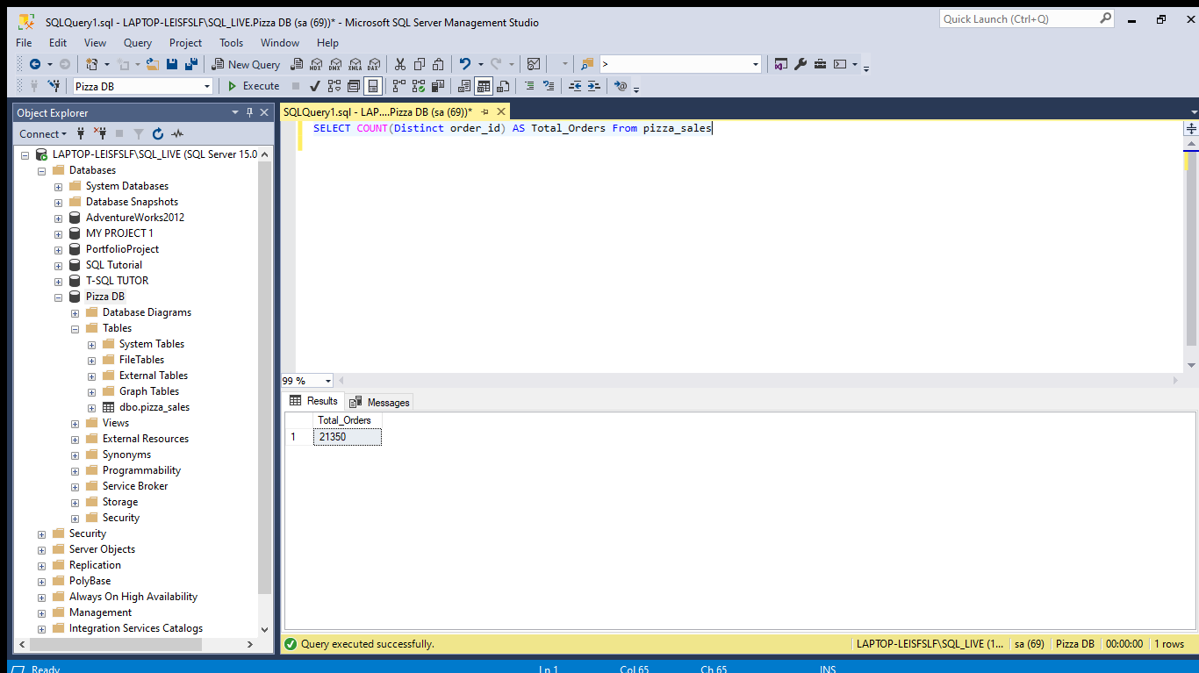

1. Average Pizza Per Order:

SELECT CAST(CAST(SUM(quantity) AS DECIMAL(10,2)) / CAST(COUNT(Distinct order_id) AS DECIMAL(10,2)) AS DECIMAL(10,2)) AS Avg_Pizza_per_Order From pizza_sales

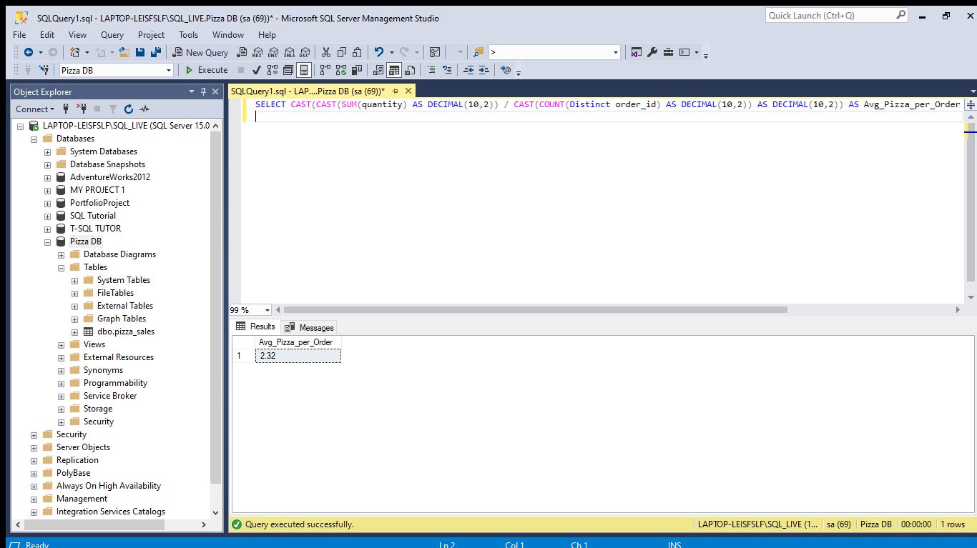

1. **Daily Trend for Total Orders**

Total Orders by Day:

SELECT DATENAME(DW, order_date) AS Order_Day , COUNT(Distinct order_id) AS Total_Orders

FROM pizza_sales

GROUP BY DATENAME(DW, order_date)

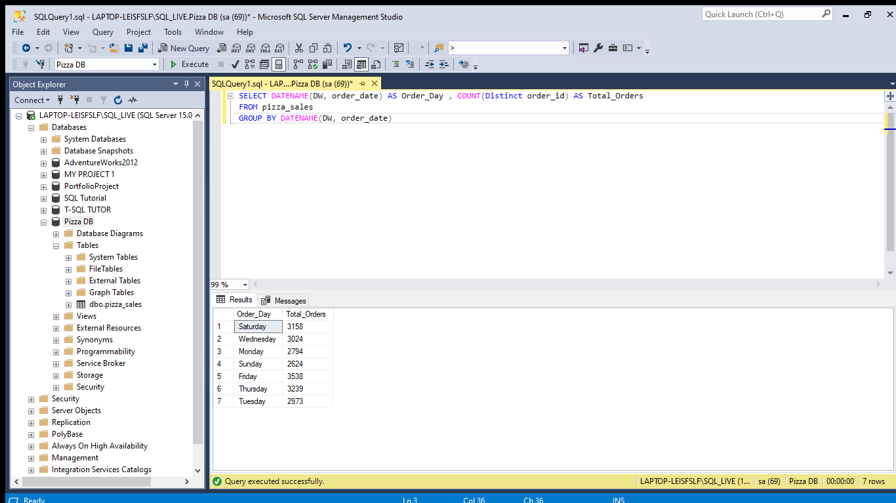

C.**Total orders by Month:**

SELECT DATENAME(MONTH, order_date) AS Month_Name , COUNT(Distinct order_id) AS Total_Orders

FROM pizza_sales

GROUP BY DATENAME(MONTH, order_date)

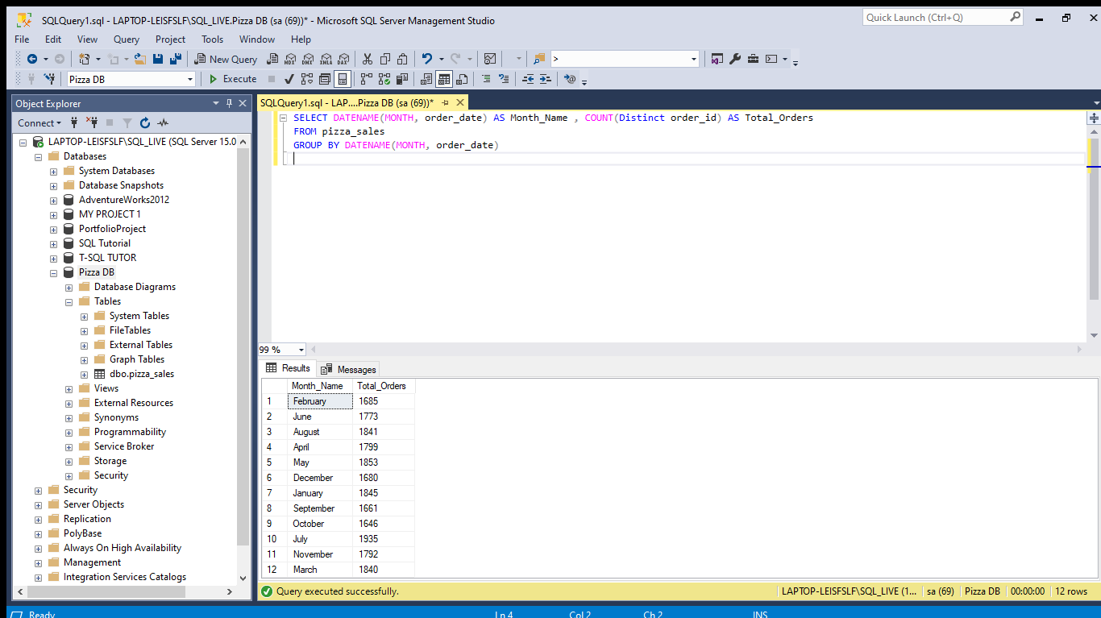

D.**Percentage of Sales by Pizza Category:**

SELECT pizza_category , SUM(total_price) AS Total_Price, SUM(total_price) * 100 / (SELECT SUM(total_price) from pizza_sales) AS PCT

FROM pizza_sales

GROUP BY pizza_category

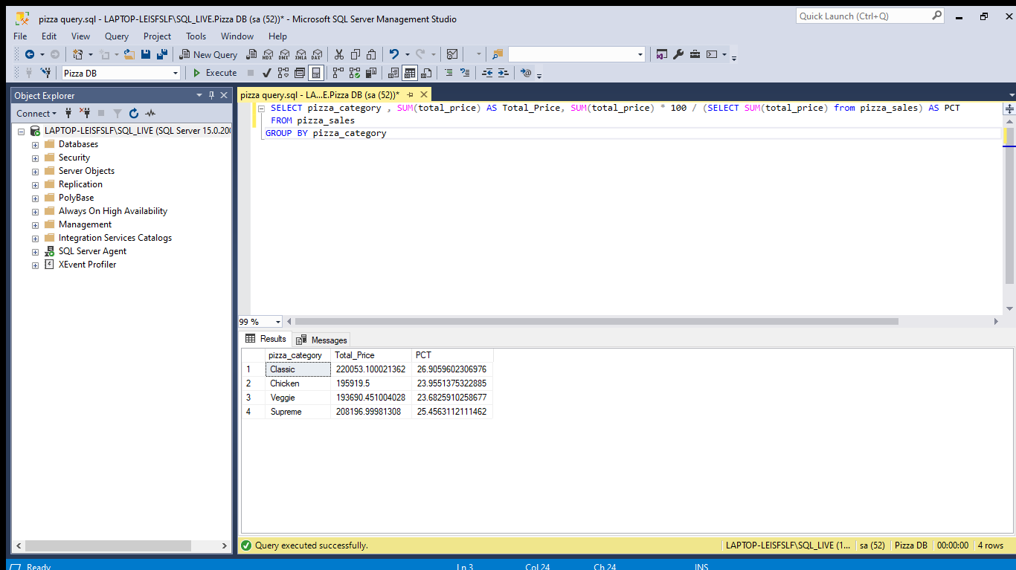

E.**Percentage of Sales by Pizza Size:**

SELECT pizza_size,CAST(SUM(total_price) as decimal(10,2)) AS Total_Price , CAST(SUM(total_price) * 100 / (SELECT SUM(total_price) FROM pizza_sales ) AS DECIMAL (10,2)) AS PCT FROM pizza_sales

GROUP BY pizza_size

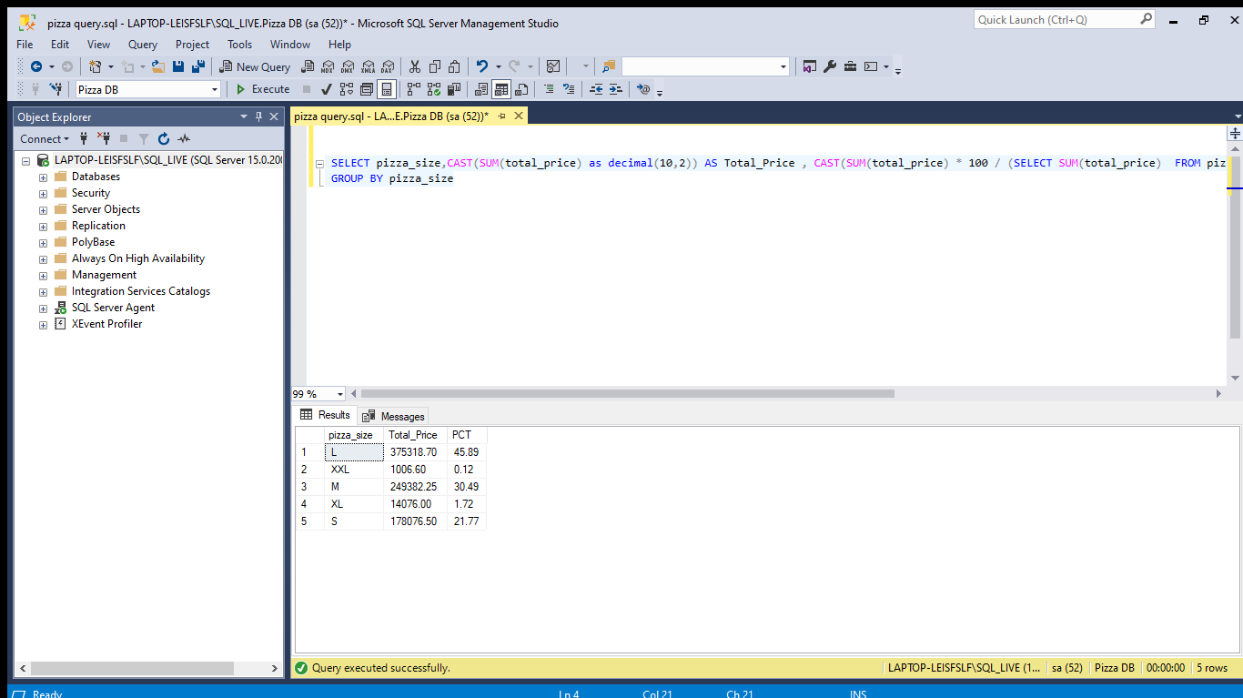

F.**Top 5 Pizza by Revenue:**

SELECT TOP 5 pizza_name, SUM(total_price) as Total_Revenue FROM pizza_sales

GROUP BY pizza_name

ORDER BY Total_Revenue DESC

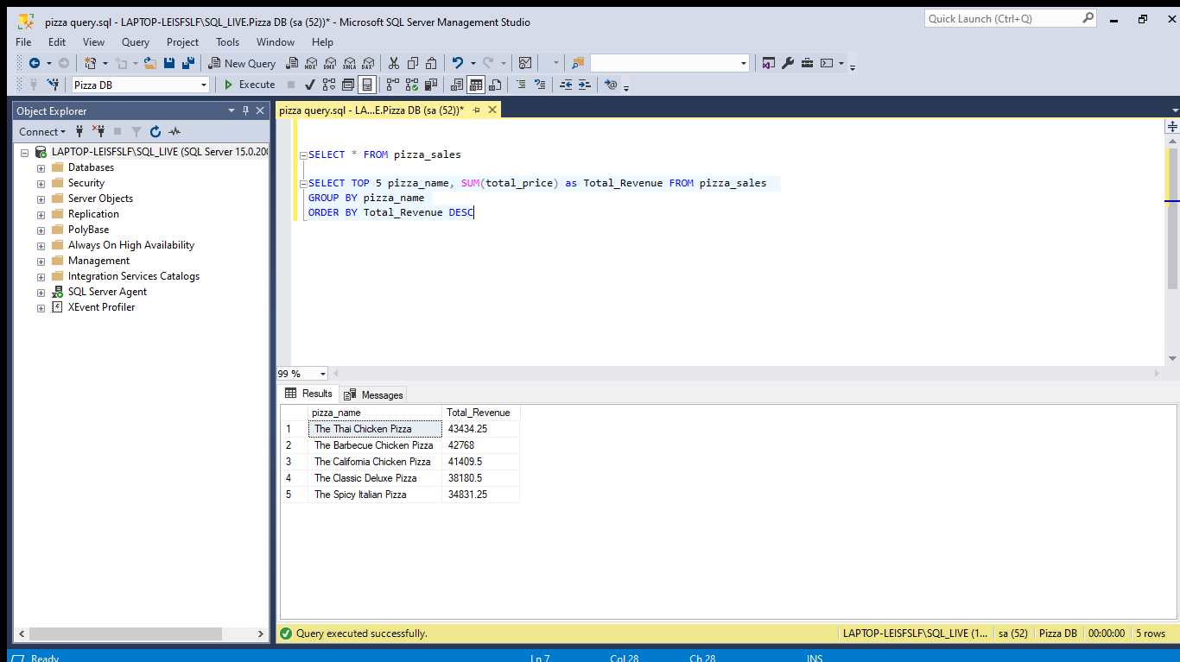

G**.Worst 5 Pizza by Revenue:**

SELECT TOP 5 pizza_name, SUM(total_price) as Total_Revenue FROM pizza_sales

GROUP BY pizza_name

ORDER BY Total_Revenue ASC

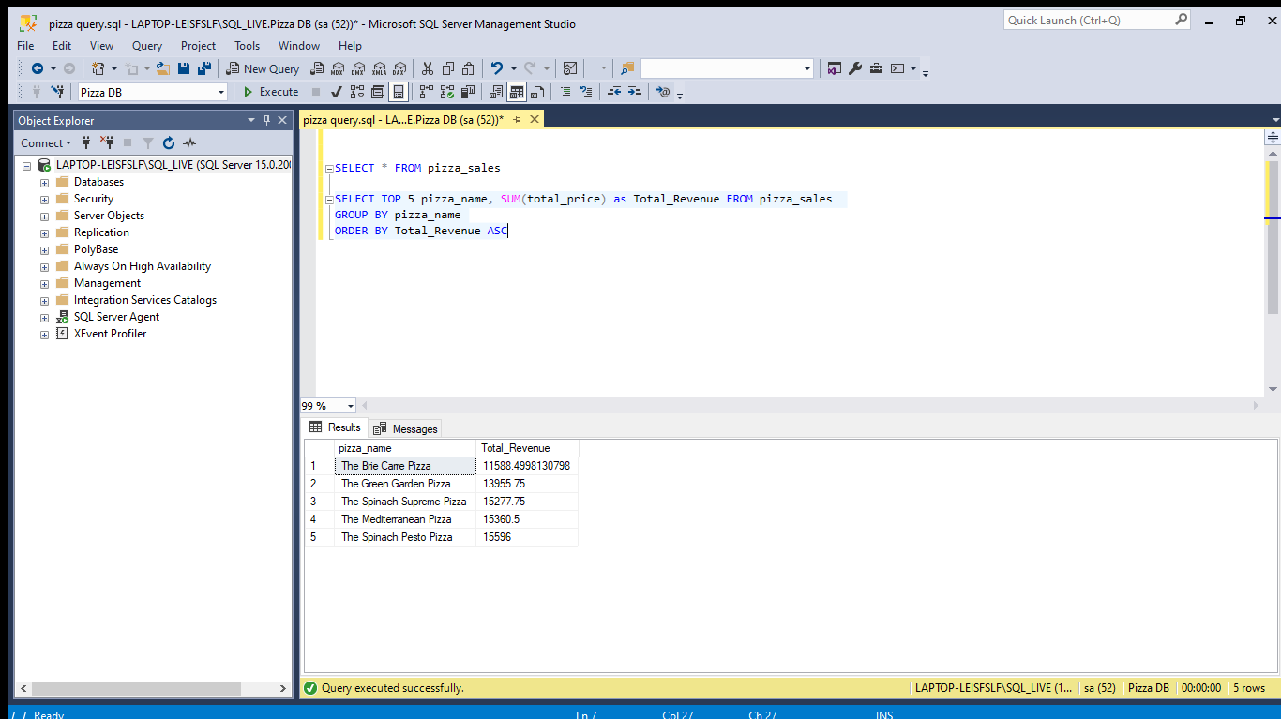

H.**Top 5 Pizza by Quantity:**

SELECT TOP 5 pizza_name, SUM(quantity) AS Total_Quantity FROM pizza_sales

GROUP BY pizza_name

ORDER BY Total_Quantity DESC

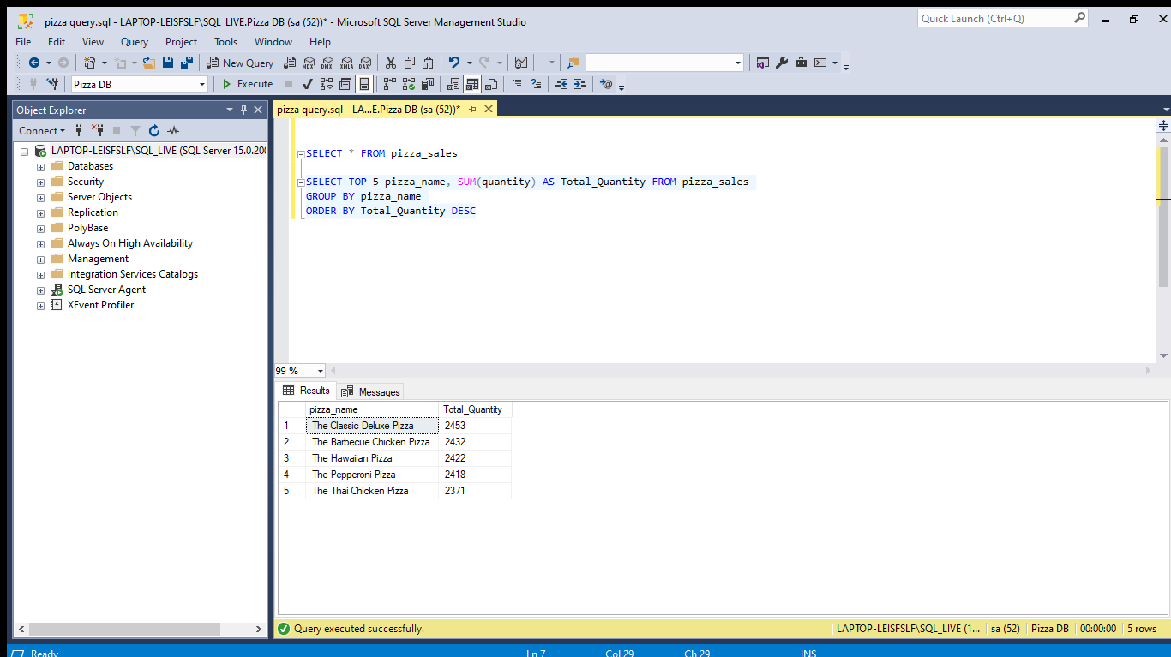

I.**Worst 5 Pizza by Quantity:**

SELECT TOP 5 pizza_name, SUM(quantity) AS Total_Quantity FROM pizza_sales

GROUP BY pizza_name

ORDER BY Total_Quantity ASC

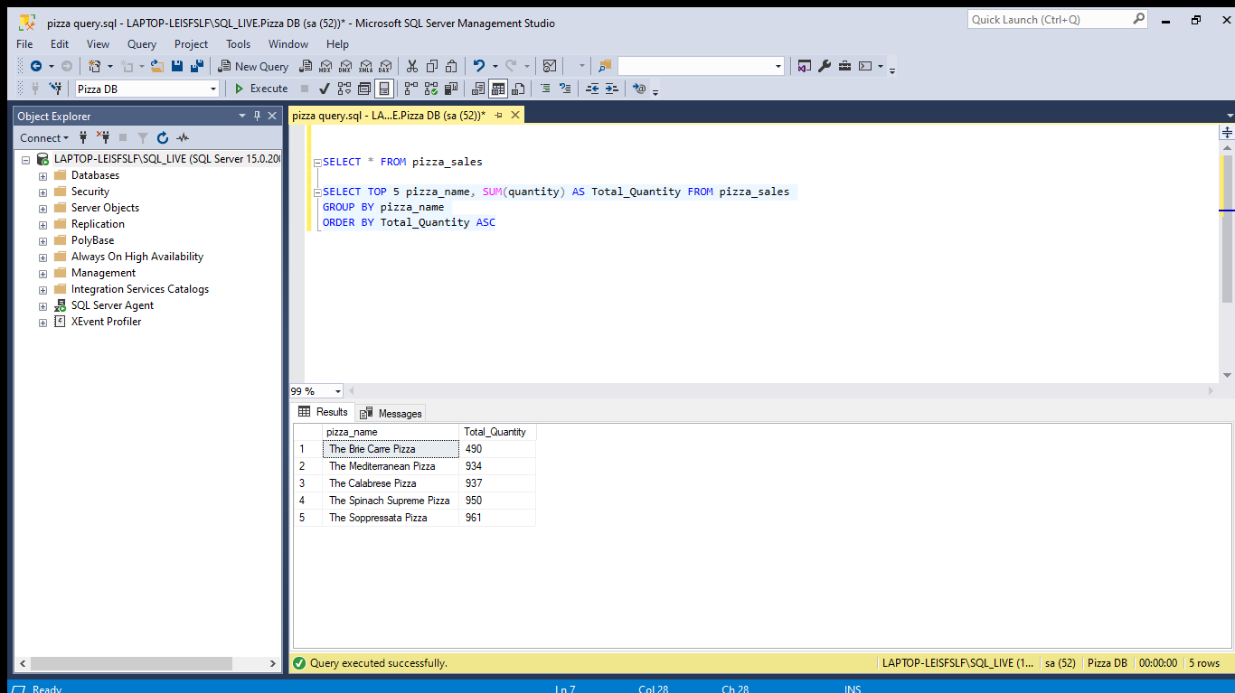

J.**Top 5 Pizza by Orders:**

SELECT TOP 5 pizza_name, COUNT(Distinct order_id) AS Total_Orders FROM pizza_sales

GROUP BY pizza_name

ORDER BY Total_Orders DESC

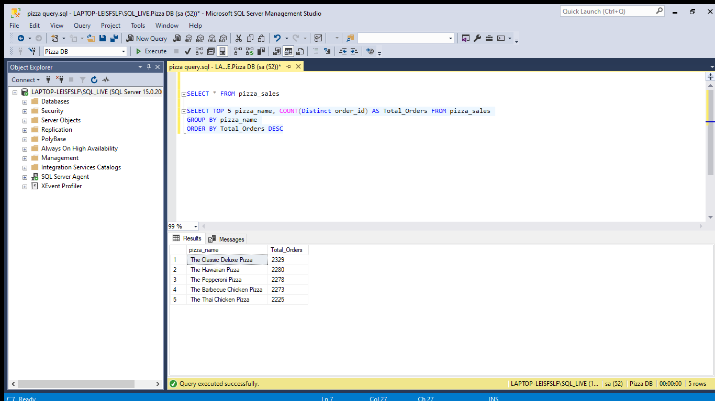

K.**Worst 5 pizza by Orders:**

SELECT TOP 5 pizza_name, COUNT(Distinct order_id) AS Total_Orders FROM pizza_sales

GROUP BY pizza_name

ORDER BY Total_Orders ASC

